

**Park Fiesta**

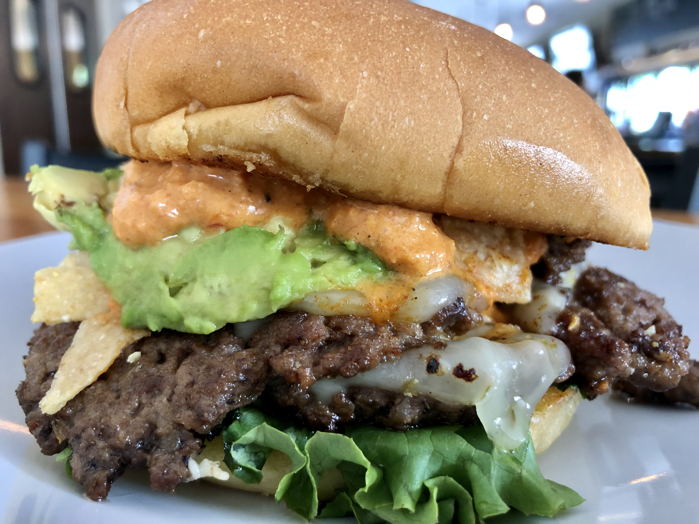

**Park style with avocado, pico de gallo, taco chips, leaf lettuce, pepper jack cheese & chipotle cream sauce. Served on a toasted bun.**

**Chicky Picky**

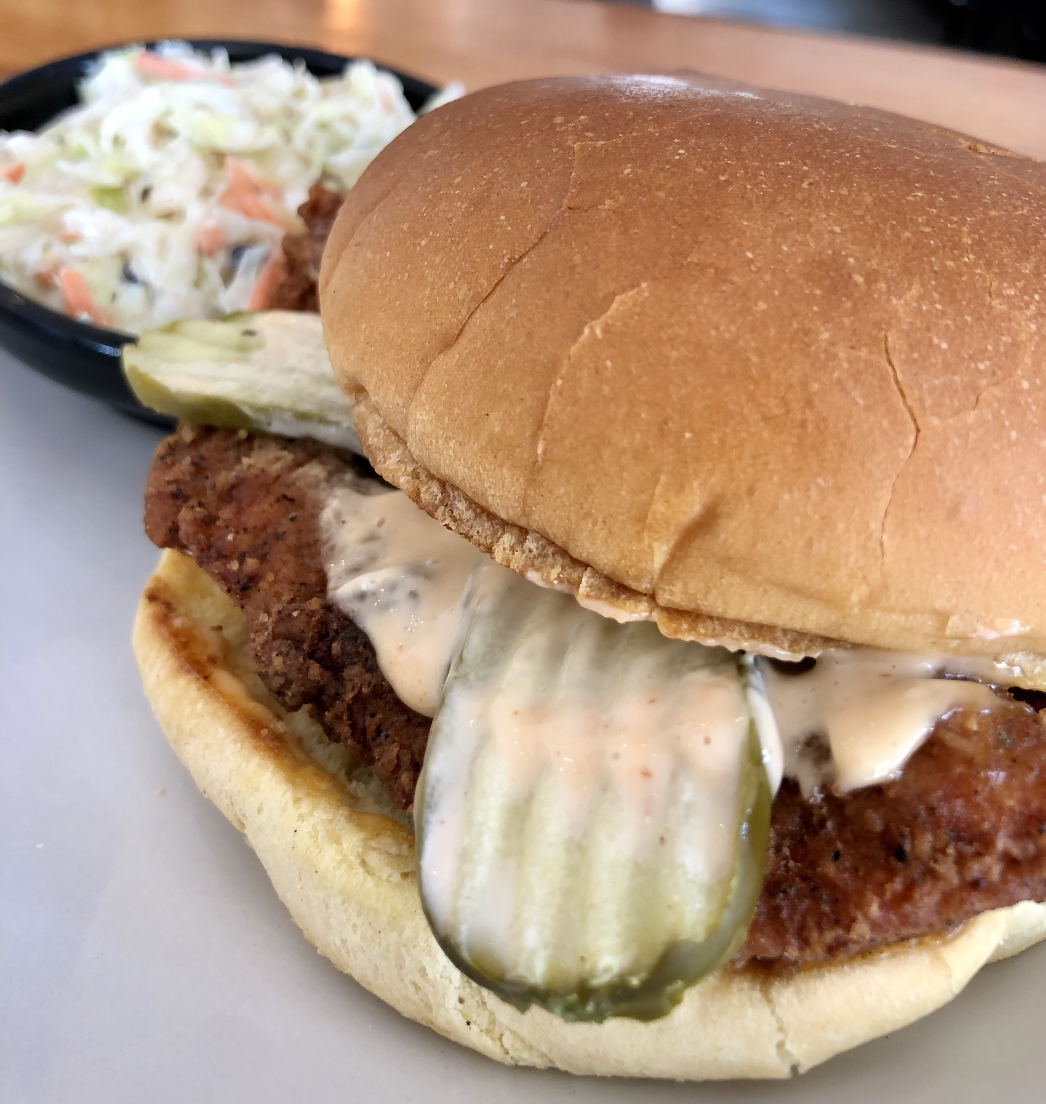

**Hand battered chicken strips, pickles & Sriracha aioli. Served on a toasted bun.**



**Fried Chicken Tacos**

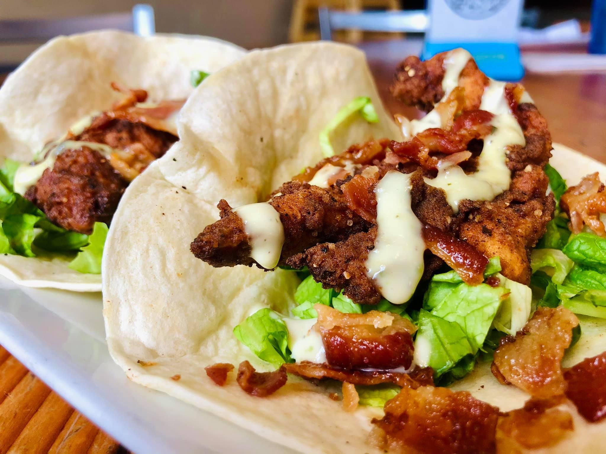

**Hand battered chicken strips, bacon, shredded leaf lettuce & avocado ranch. Served in a flour tortilla.**