Green Chile Cheeseburger
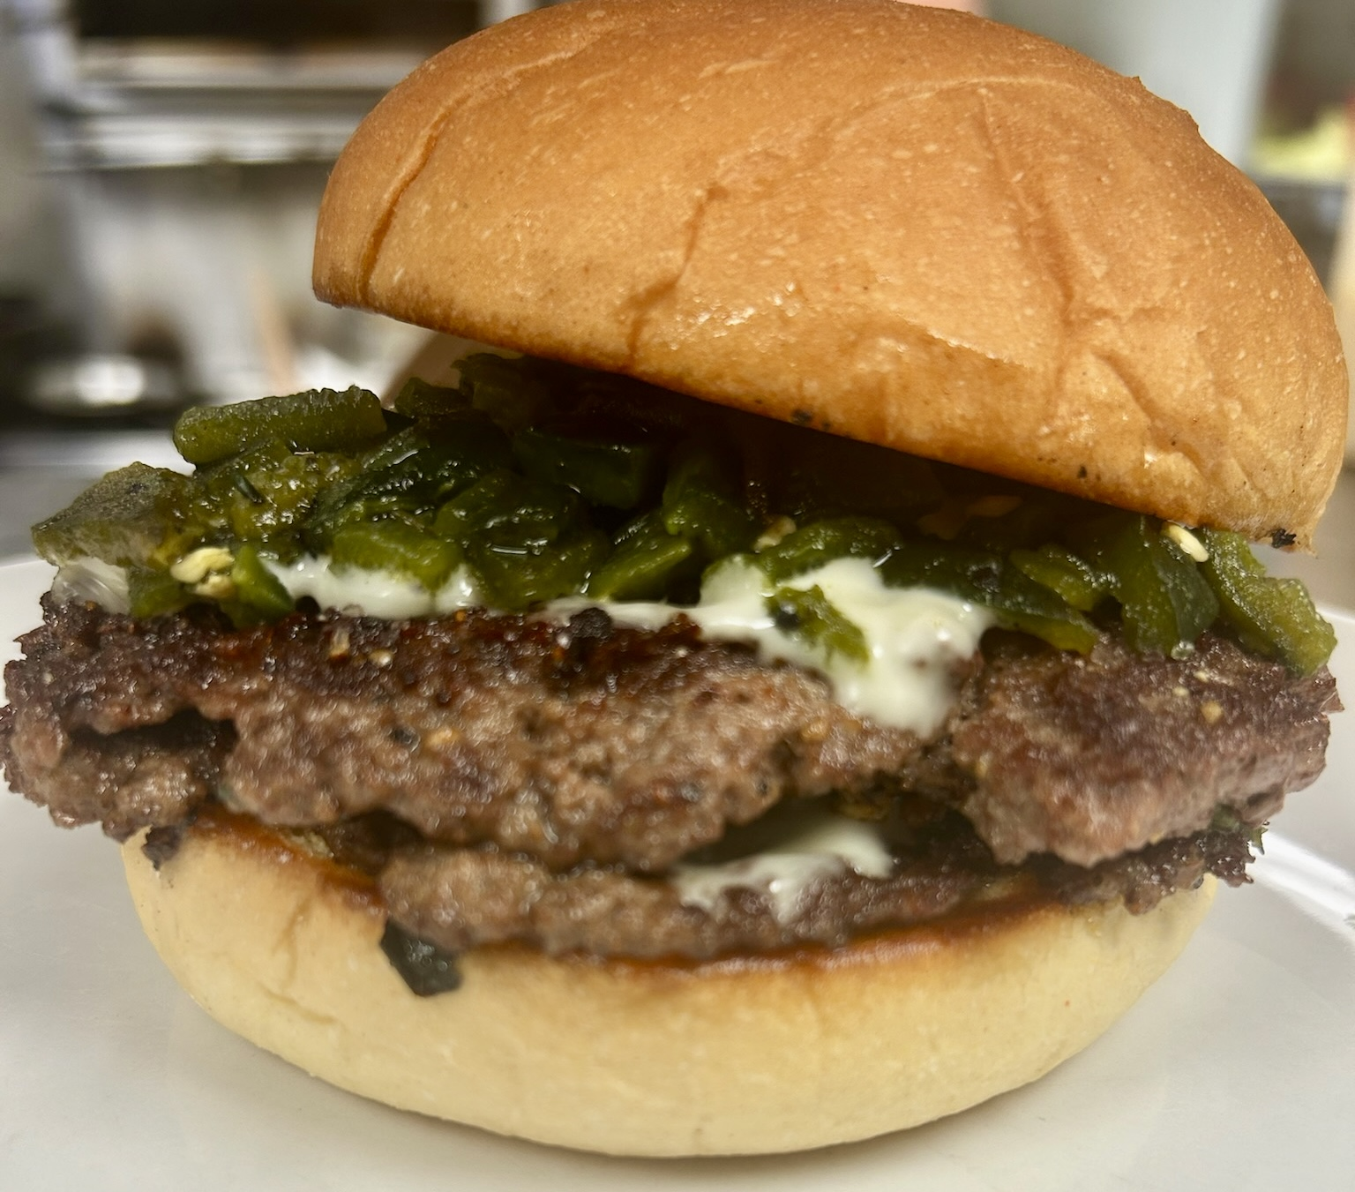

Two smashed burger patties, roasted green chiles & Provel cheese. Served on a toasted bun.

Animal Style Fries
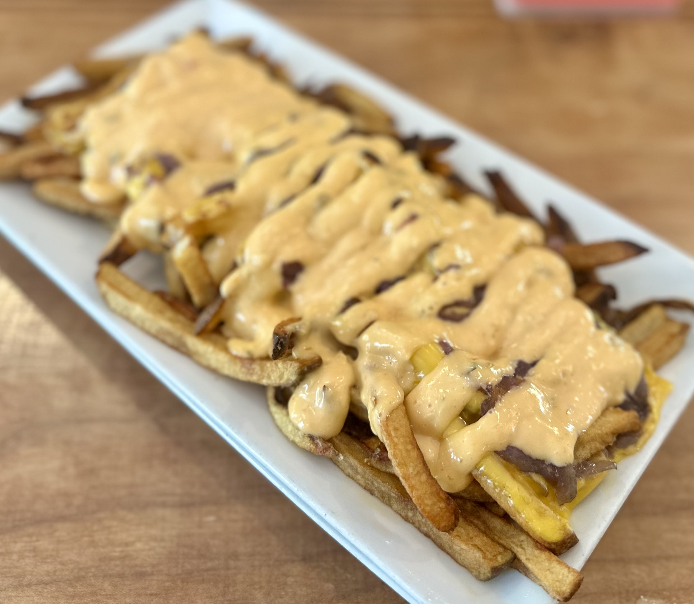

House cut fries topped with melted American cheese, caramelized onions and house made thousand island.

Pasta Salad
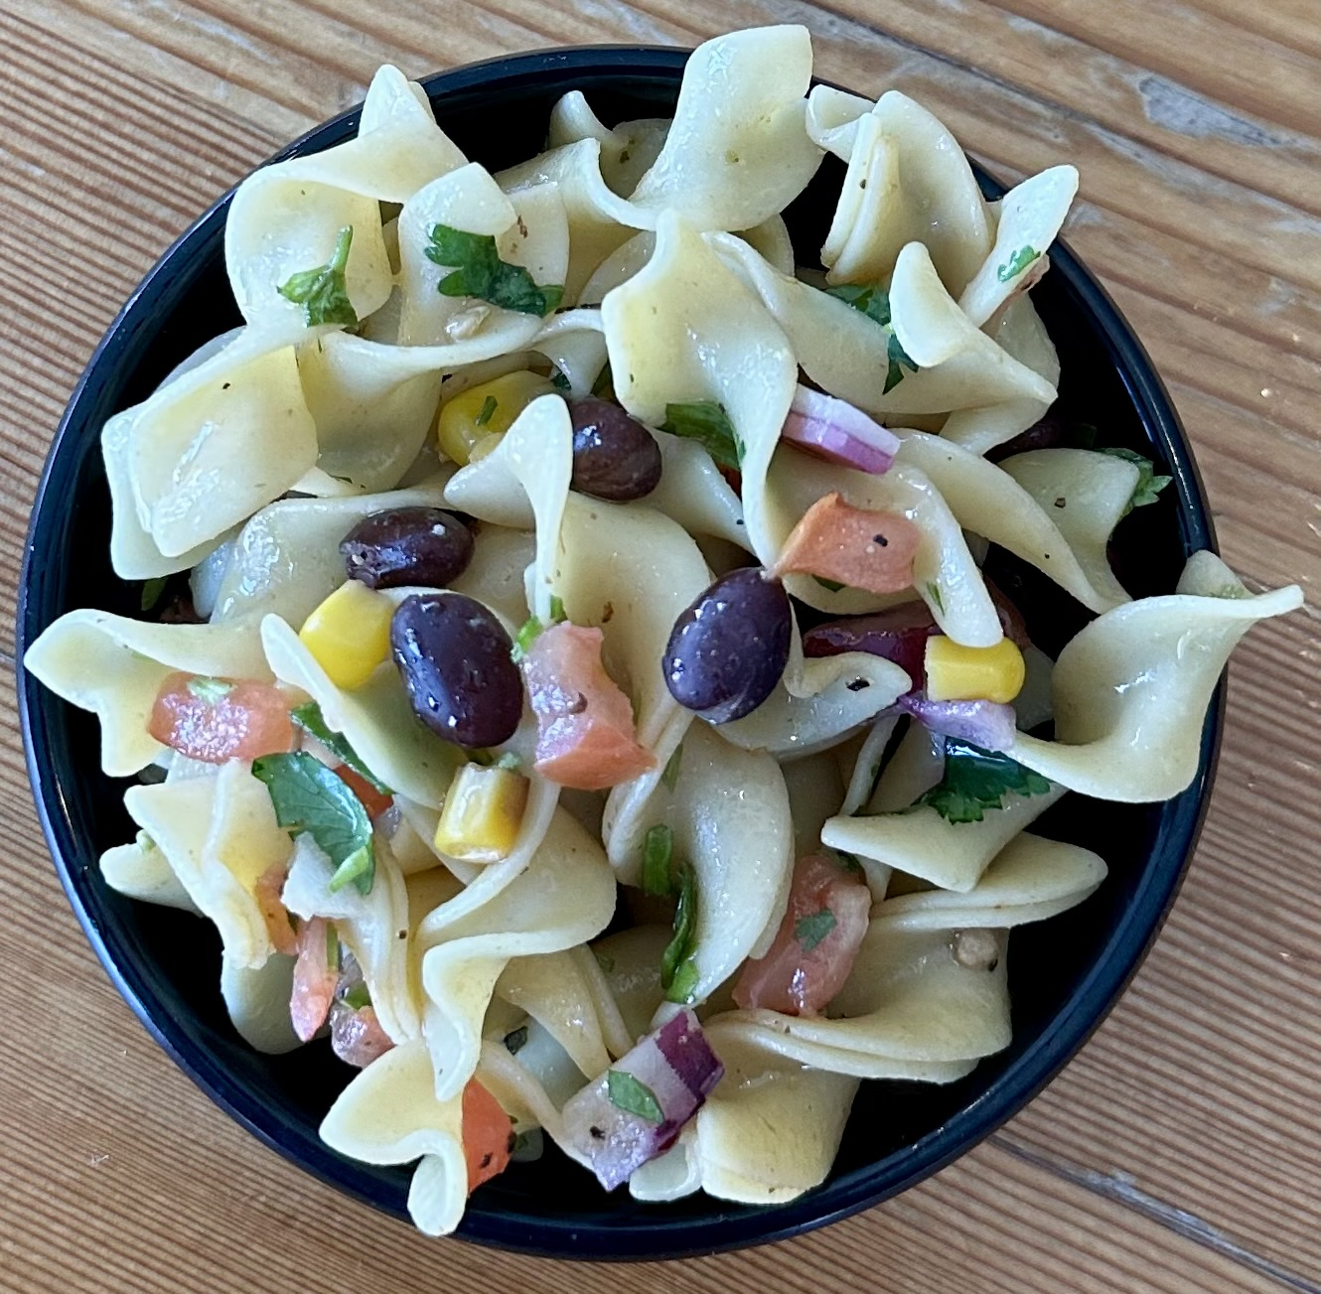

House made.
*optional- add queso fresco crumbles*

